Code Example 1: Auto Scaling in Medical Image Feature Analysis
A team of radiologists is working with a dataset of extracted features from brain MRI images to classify the presence of tumors. Two features are considered:
• Feature1: Tumor area in mm²
• Feature2: Average pixel intensity in the suspected region

Problem: The raw feature values have different units and scales — tumor area ranges from 10 to 50, while pixel intensities range from 160 to 200. Feeding such data directly into a machine learning model may cause bias towards larger-scale features, degrading performance.
Solution: The team uses StandardScaler (Z-score normalization) to scale features to a common distribution with mean 0 and standard deviation 1. This improves the accuracy of SVM and logistic regression classifiers used for tumor classification.
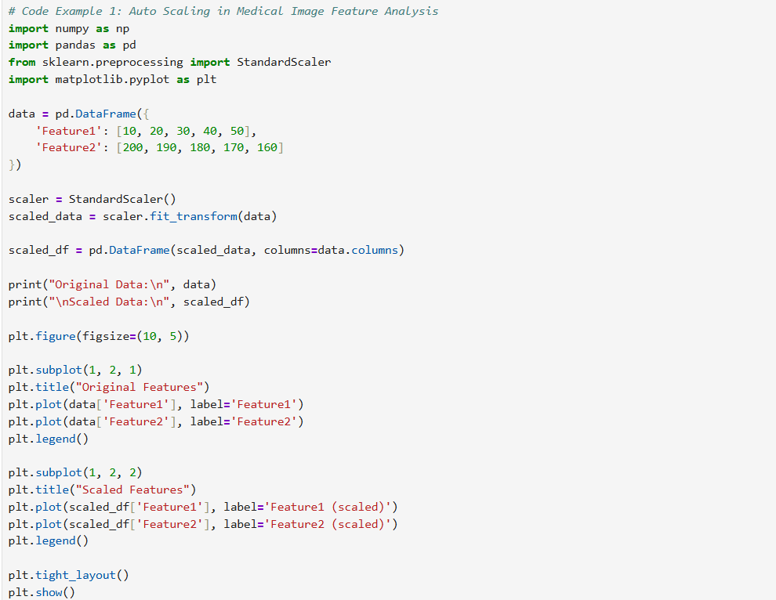

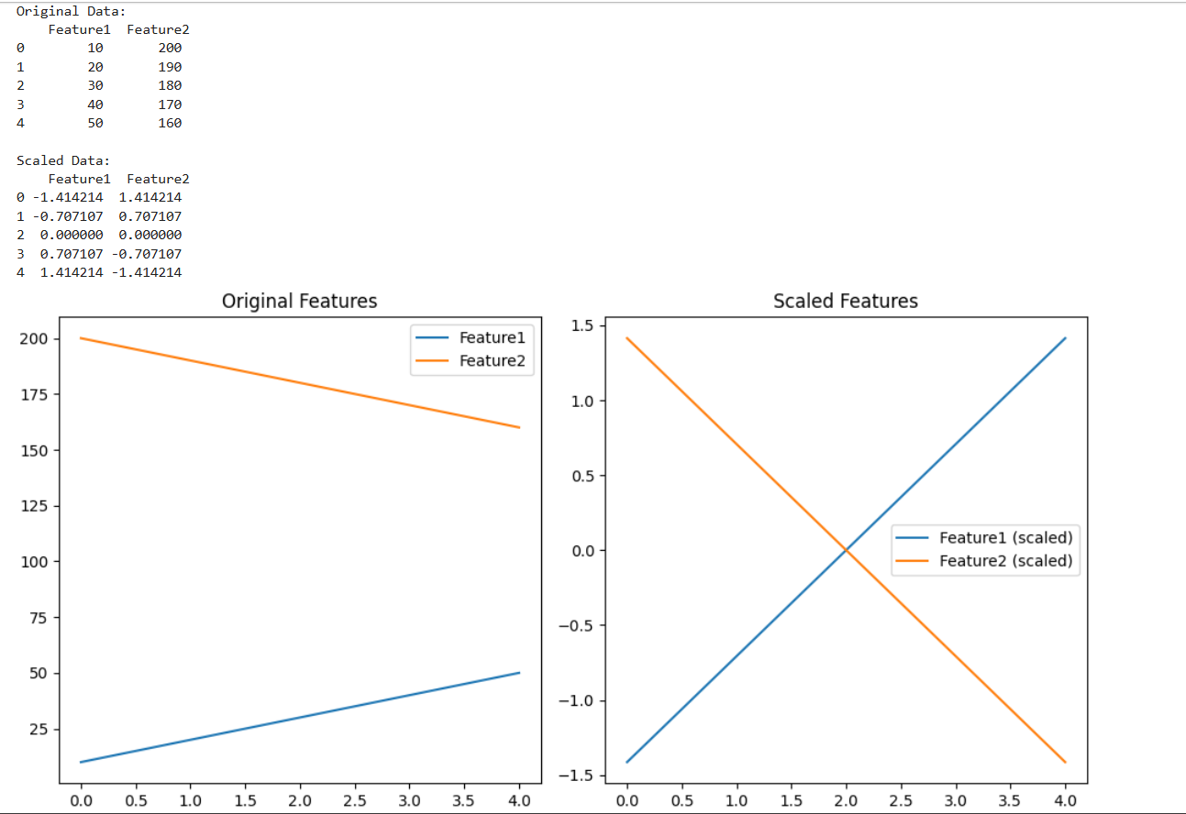

Code Example 2: Detecting Cyclic Patterns in Industrial Sensor Data
A manufacturing plant uses a vibration sensor to monitor the operation of a rotating machine. Every second, the sensor records the vibration level of the machine. Engineers suspect that there might be a repeating pattern (cyclic behavior) in the machine’s operation that could indicate early signs of wear or mechanical imbalance.
Objective
Use autocorrelation analysis to identify if the sensor data exhibits a repetitive pattern over time, which could hint at a periodic mechanical issue.
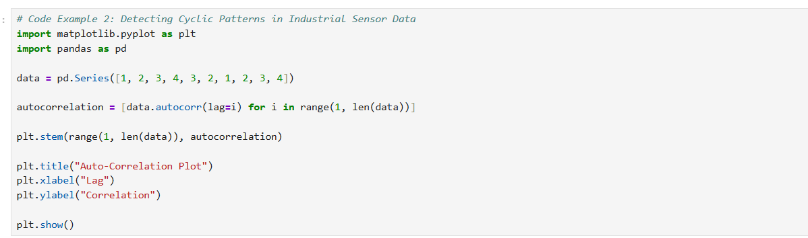

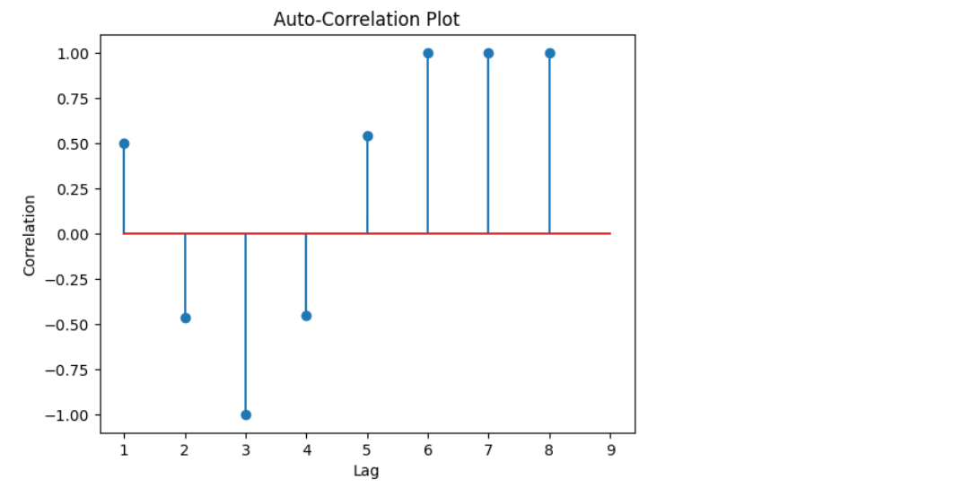

Code Example 3: Identifying Repetitive Patterns in a Production Line Sensor
Company: AutoLine Robotics Pvt. Ltd. Department: Production Engineering Machine: Robotic arm used in assembly line operations Sensor: Vibration sensor attached to the base of the robotic arm Frequency of data collection: Every second
Business Problem
Recently, maintenance engineers noticed a pattern of unusual wear and tear in a specific robotic arm. While there was no immediate fault detected, the wear appeared in cyclical bursts. They hypothesized that the arm may be undergoing hidden repetitive stress not visible in standard inspection. To validate this, they decided to analyze vibration data using autocorrelation to detect any underlying patterns.
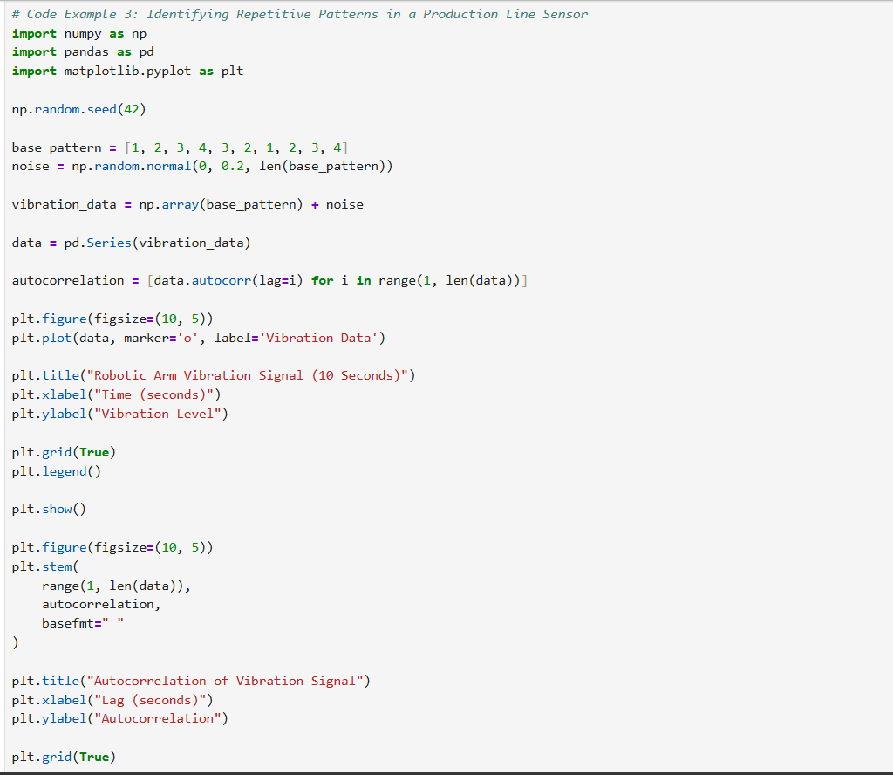

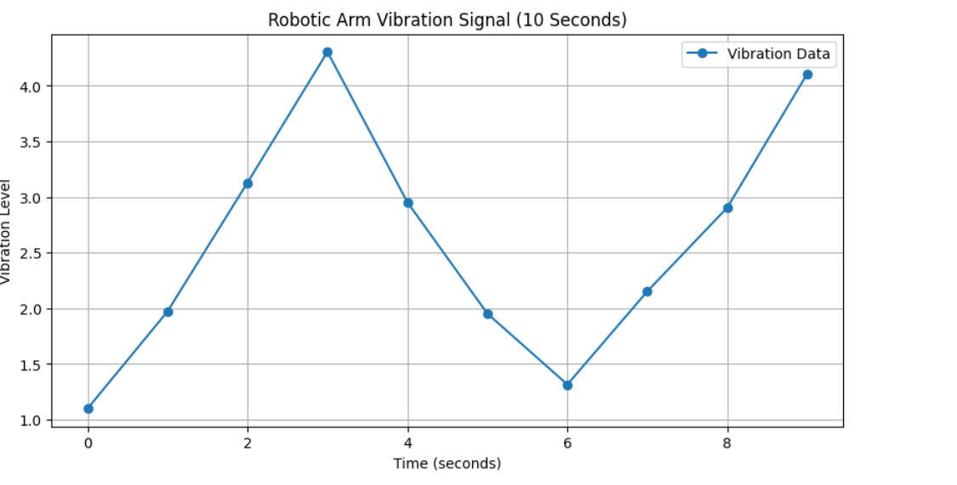

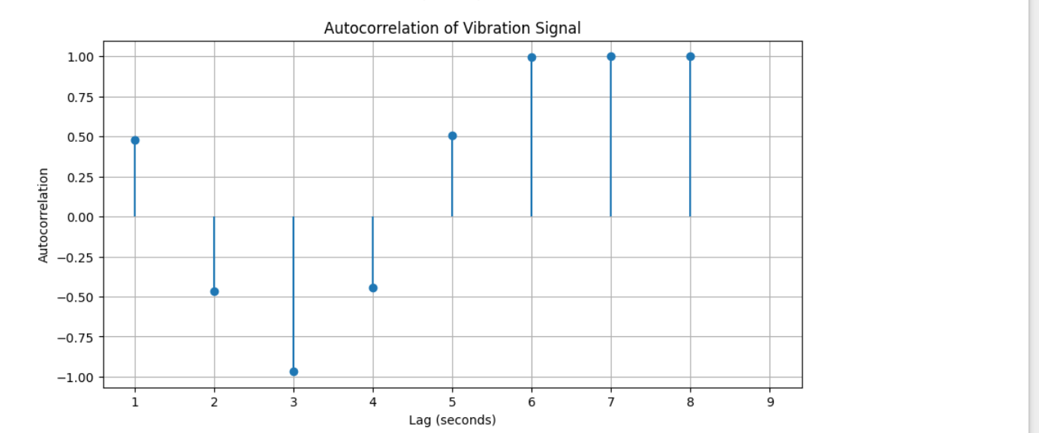

Case Study 1: Medical Diagnosis Data Normalization
A hospital is building a machine learning model to classify patient health conditions based on vital signs such as:
• Heart rate (in bpm),
• Body temperature (in °C),
• Blood pressure (in mmHg).

However, these values have different scales, which leads to poor model performance. To fix this, they apply data normalization (auto-scaling) using StandardScaler.
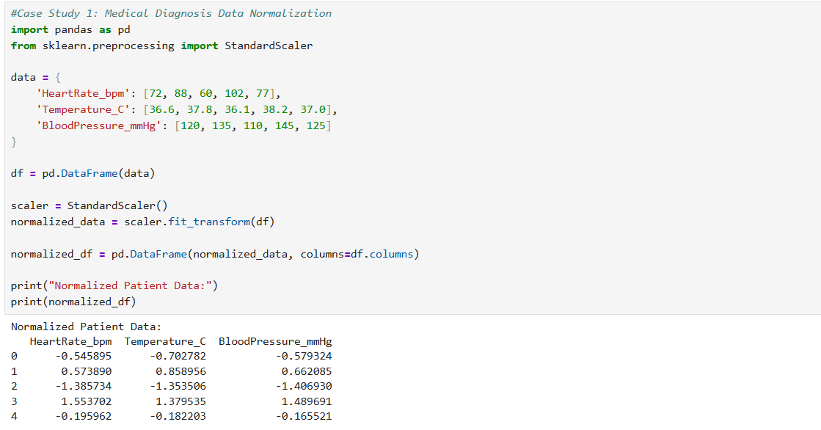

Case Study 2: Seasonal Pattern Detection in Weather Data
A meteorological department wants to analyze daily temperature patterns to detect seasonal trends and cycles (e.g., summers and winters). By using autocorrelation, they aim to identify the seasonal lag.
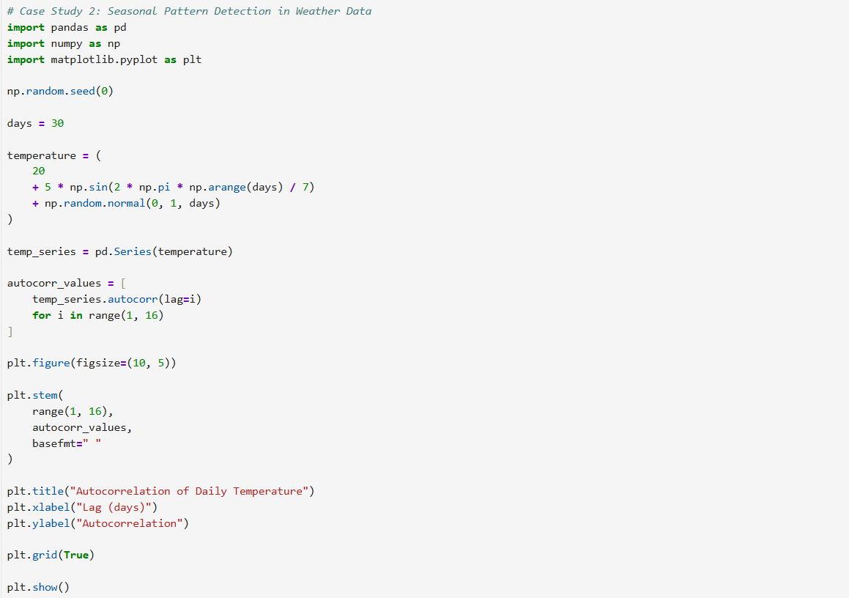

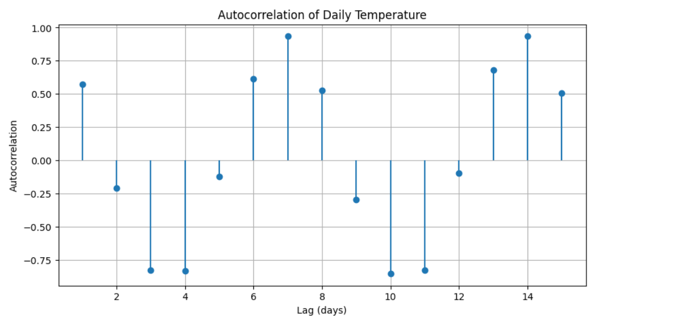

Case Study 3: Credit Scoring in Finance
A bank uses features like credit history, income, and age to determine a person's credit score. However, not all features are equally important:
• Credit history is more predictive than age.
• Feature weighting improves model accuracy in logistic regression.
